In Depth Research Report: XSS & HTML Injection.

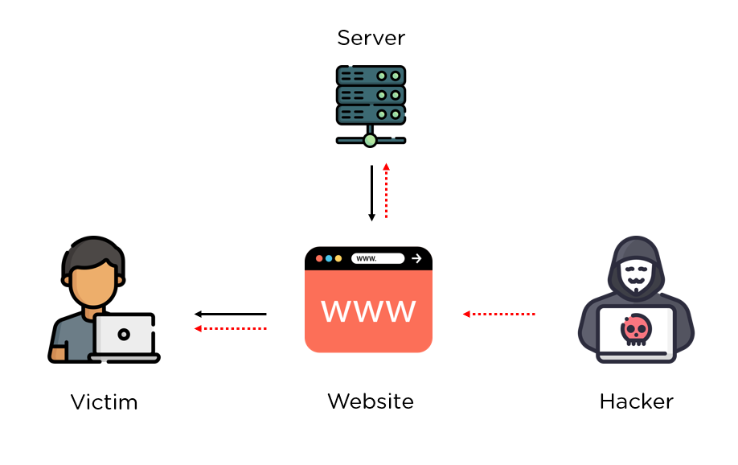

Introduction
Cross-Site Scripting (XSS) and HTML Injection are critical security vulnerabilities that affect web applications, allowing attackers to inject malicious scripts or code. These vulnerabilities can have severe implications, including data theft, session hijacking, and defacement of web pages. Understanding these attacks, their types, and effective mitigation strategies is essential for securing web applications.

Outcome

1. What is HTML Injection (HTMLi)?
HTML Injection (HTMLi) is a type of vulnerability that occurs when an attacker can inject malicious HTML code into a web page due to improper handling of user input. Unlike XSS, where attackers embed scripts, HTMLi focuses primarily on altering the structure or appearance of a web page. HTML Injection can result in manipulated content on the web page or execution of unintended behaviors within the application.

Example of HTML Injection:
<!-- Original HTML -->
<p>Welcome to the site, John Doe!</p>

<!-- Injected HTML -->
<p>Welcome to the site, <h1>Hacked!</h1></p>

In this scenario, the attacker alters the webpage by injecting <h1> tags, resulting in the modification of the content and design of the page.

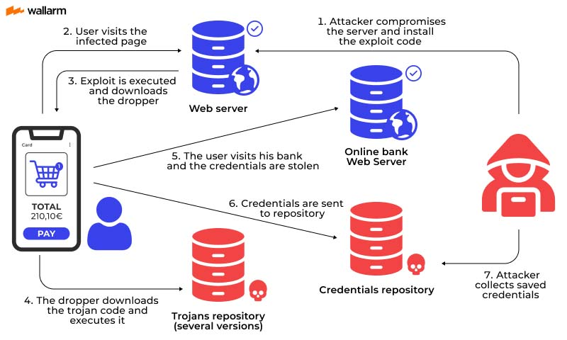

2. What is XSS and Types of XSS?
Cross-Site Scripting (XSS) occurs when an attacker injects malicious scripts into web applications, often through user input fields. These scripts are executed in the victim's browser, allowing the attacker to perform a variety of actions, such as stealing cookies or impersonating the user. XSS can occur due to inadequate input sanitization.

Types of XSS:
1.Stored XSS: Stored XSS happens when a malicious script is permanently stored on the target server (e.g., in a database, message forum, or comment section). When the script is retrieved by other users, it gets executed in their browsers without their knowledge.
Example: A comment section that displays a user’s input without proper sanitization could allow an attacker to inject JavaScript code, which would be executed by every user viewing that comment.
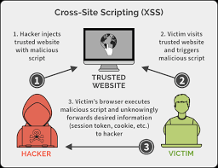
2. Reflected XSS: Reflected XSS occurs when a malicious script is reflected off a web server, typically via a web request, and executed in the victim’s browser. It often happens when an attacker sends a malicious URL to the victim, which includes an embedded script.
Example: A search bar that includes user input in its response page could allow an attacker to send a URL with a script embedded, leading to the execution of that script when the victim clicks the link.
3. DOM-based XSS: DOM-based XSS occurs when the vulnerability exists within the client-side code, such as JavaScript. The attacker manipulates the DOM environment in the victim's browser, which results in the execution of malicious scripts.
Example: A webpage that uses document.write() to display user-provided input could allow an attacker to inject malicious JavaScript that is executed directly in the user's browser.

3. What are Input Validation Attacks?
Input validation attacks occur when attackers exploit web applications by providing unexpected inputs, such as malicious code, that are not properly validated or sanitized by the application. These attacks can lead to various vulnerabilities, including SQL injection, XSS, and HTML Injection.
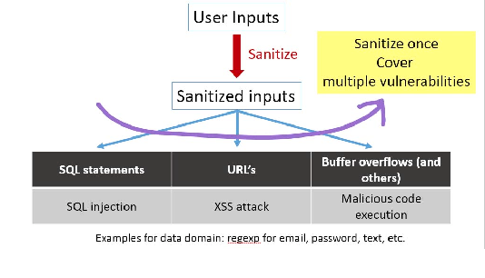
Common types of input validation attacks include:
- SQL Injection: Involves injecting malicious SQL queries into user input fields.
- Command Injection: Injecting system commands into input fields to be executed on the server.
- Cross-Site Scripting (XSS): Injecting malicious scripts to execute in the client’s browser.
- HTML Injection: Injecting HTML tags to modify the structure of a webpage.

4. Impact and Mitigation Measures

Impact:
- Data theft: Attackers can steal sensitive information such as cookies, session tokens, or user credentials.
- Session hijacking: Attackers can impersonate legitimate users by stealing session cookies.
- Defacement: Attackers can alter the content or structure of a webpage.
- Phishing attacks: Malicious scripts can be used to redirect users to fake websites to steal login credentials.

Mitigation Measures:
Input Validation: Ensure that all input is properly validated and sanitized. Never trust user input, whether it comes from forms, cookies, HTTP headers, or URL parameters.
  - Escaping: Convert special characters (e.g., <, >, &, ', ") to their corresponding HTML or URL-encoded entities.
  - Use of Parameterized Queries: For database queries, use prepared statements and parameterized queries to prevent SQL Injection.
Content Security Policy (CSP): Implement a strong Content Security Policy to prevent the execution of unauthorized scripts.
Output Encoding: Ensure that any data coming from user inputs that are rendered on the webpage is properly encoded. This prevents injected scripts or HTML from being executed in the browser.
Web Application Firewalls (WAFs): WAFs can be used to detect and block malicious requests targeting known vulnerabilities.
Regular Security Audits and Penetration Testing: Regular testing and auditing of the codebase and application help identify potential security issues, including XSS and HTMLi vulnerabilities.

5. WAF Bypass Methods
A Web Application Firewall (WAF) can protect against various types of attacks, including XSS. However, attackers often find ways to bypass WAFs using advanced techniques. Some common methods include:
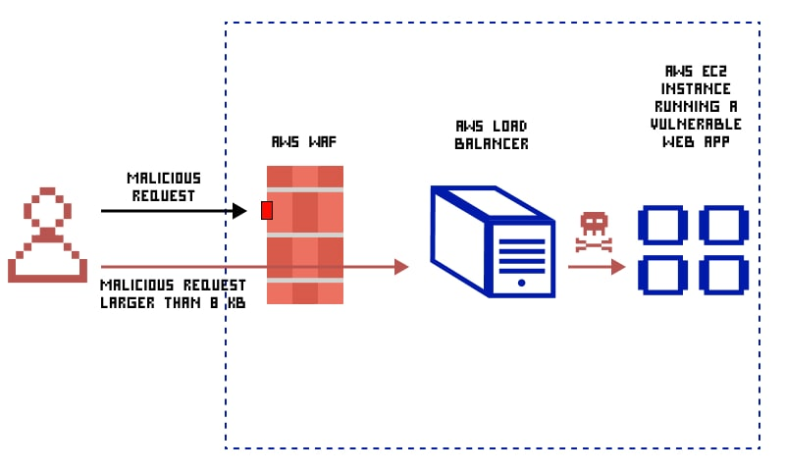

Encoding Payloads: Attackers may encode payloads in Base64, URL-encoding, or hexadecimal to bypass WAF signature detection.
. Example
<script>eval(atob('ZG9jdW1lbnQuY29va2llPQ=='))</script>
Using Alternate Tags or Attributes: Attackers may use non-traditional HTML tags or attributes to inject scripts.

Example: Using <img> tag with an onerror attribute to execute malicious code:
<img src="invalid-image" onerror="alert('XSS')" />
Nested or Chained Scripts: Attackers may chain multiple payloads together or nest scripts in an attempt to bypass detection.
Example:
<script>document.write("<scr"+"ipt>alert('XSS')</scr"+"ipt>");< /script>
Obfuscation: Attackers may obfuscate code by splitting it into chunks or using JavaScript functions to reconstruct the payload.
Example:
<script>var a = "a"+"lert"; window[a]('XSS');</script>

Conclusion
XSS and HTML Injection are critical vulnerabilities that can lead to serious security breaches if left unchecked. By implementing proper input validation, output encoding, and using security tools like WAFs and CSPs, developers can mitigate the risks associated with these vulnerabilities. Regular security audits and awareness of bypass techniques are crucial to ensuring the robustness of web applications against modern attacks.

References
- OWASP. (n.d.). Cross-Site Scripting (XSS). Retrieved from https://owasp.org/www-community/attacks/xss/
- Acunetix. (2023). Cross-site scripting (XSS) attacks: Types and prevention. Retrieved from https://www.acunetix.com/blog/articles/cross-site-scripting/
- PortSwigger. (n.d.). What is cross-site scripting (XSS)?. Retrieved from https://portswigger.net/web-security/cross-site-scripting
- OWASP. (n.d.). HTML Injection. Retrieved from https://owasp.org/www-community/attacks/HTML_Injection

